My presentation on the topic XY : Criteria for the evaluation of partially translated or machine-generated texts

These two grids are designed to a) assess yourself and b) have the teacher assess you at these two points in time:
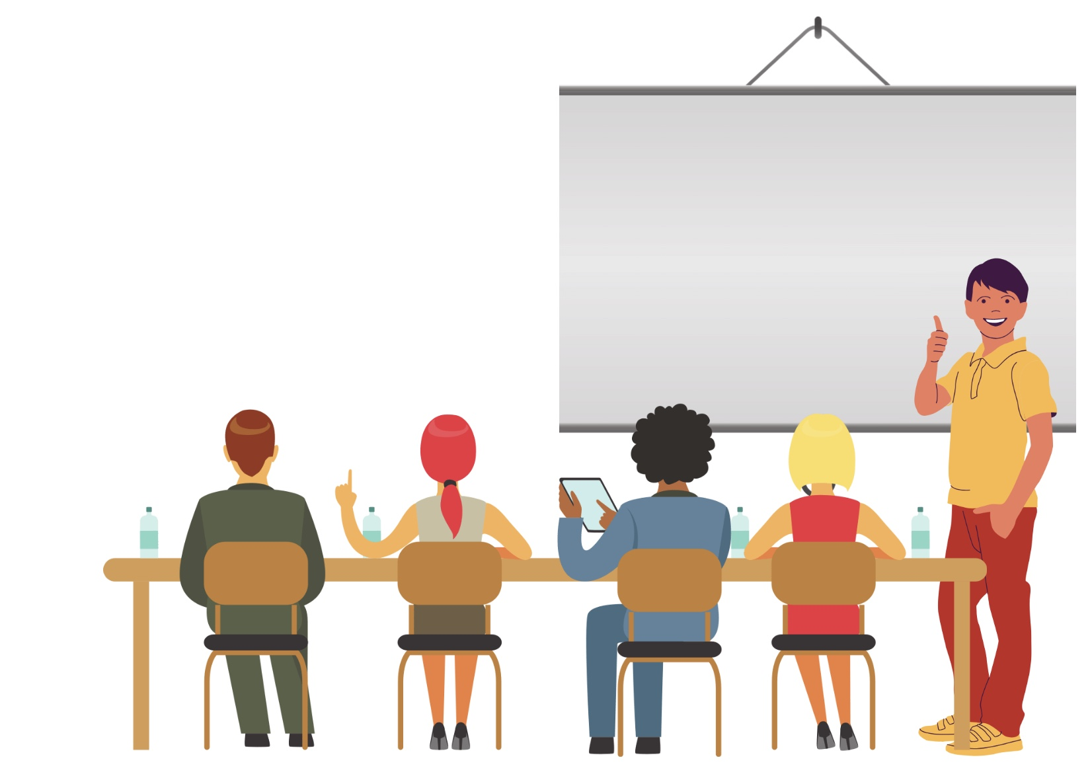  PART 1: Your oral presentation to the class or in audio or video form. | PART 2: Your oral interview with the teacher.

PART 1: ORAL PRESENTATION
AUTHENTICITY | I identify with what I say and the audience has no doubt that I am expressing my own thoughts:  ● completely  ● for the most part  ● Partly  ● little or not at all | 3  2  1  0
APPROPRIATENESS IN RELATION TO THE SITUATION*. | The language I use to express my thoughts is appropriate for a presentation (the register is formal, the sentences are not too complex to be understood orally, the length and scope of the presentation are as specified, etc.):  ● completely  ● for the most part  ● Partly  ● little or not at all | 3  2  1  0
APPROPRIATENESS IN RELATION TO THE TARGET GROUP** | The language I use to express my thoughts is understood by the target group (e.g. the students in my class and the teacher):  ● completely  ● for the most part  ● Partly  ● little or not at all | 3  2  1  0
MEDIA USE | The media I use promote understanding:  ● completely  ● for the most part  ● Partly  ● little or not at all | 3  2  1  0
STRUCTURE | I introduce the topic, divide my report into several parts and end with a summary conclusion:  ● completely  ● very good  ● good  ● Only partially | 3  2  1  0
KOHESION | The text sections are well connected and the chosen style is maintained throughout the text:  ● completely  ● almost always  ● Partly  ● little or not at all | 3  2  1  0
RETORIQUE | I can keep the audience's attention (e.g. through originality, surprises, cliffhangers, questions to the audience, free delivery without reading off, etc.):  ● completely  ● almost always  ● Partly  ● little or not at all | 3  2  1  0
PRONONATION | My pronunciation of words and sentences....  ● is perfect (I practised with text-to-speech programmes)  ● is largely correct and has minor deficiencies  ● is characterised by several imperfections  ● is characterised by numerous imperfections | 3  2  1  0
VOCABULAR | I use a vocabulary  ● precise and contextual, with some hard-to-avoid shortcomings***.  ● Sometimes inappropriate and repetitive, with some easily avoidable shortcomings  ● Sometimes inappropriate and repetitive, with several easily avoidable shortcomings  ● Mostly inappropriate or repetitive, with easily avoidable deficiencies | 3  2  1  0
GRAMMAR AND SPELLING | I do...  ● No or few difficult to avoid errors***  ● few easily avoidable errors  ● some easily avoidable mistakes  Too many easily avoidable mistakes | 3  2  1  0
TOTAL: _______ / 30 POINTS

MARK OF THE PRESENTATION: _________ POINTS: 5 = ___________

PART 2: DISCUSSION AFTER THE PRESENTATION
UNDERSTAND | I show that I understand my subject and can make it understandable:  ● completely  ● for the most part  ● Partly  ● little or not at all | 3  2  1  0
ANALYSIS | I show that I can analyse my subject:  ● completely  ● for the most part  ● Partly  ● little or not at all | 3  2  1  0
INTERPRETATION / TRANSMISSION | I show that I can draw conclusions, that I can transfer my knowledge to other areas:  ● completely  ● for the most part  ● Partly  ● little or not at all | 3  2  1  0
FLUENCE | I speak fluently  ● completely  ● good  ● Partly  ● little | 3  2  1  0
INTERACTION | I can maintain dialogue, ask for clarification, respond flexibly and understand the other person's needs  ● completely  ● very good  ● discrete  ● little or not at all | 3  2  1  0
PARTICIPATION | I show and explain my convictions, interest and commitment in a convincing and understandable way  ● always  ● Frequently  ● little  ● not at all | 3  2  1  0
WORDSHEET | My vocabulary is  ● Precise and diverse  ● adequate, with some shortcomings  ● Poor and repetitive  ● limited | 3  2  1  0
GRAMMATICS | Grammar - I do...  ● some minor errors  ● some mistakes, but no misunderstandings  ● numerous errors that make comprehension somewhat difficult.  ● too many errors for the required language level. | 3  2  1  0
TOTAL: _______ / 30 POINTS

DISCUSSION MARK: _________ POINTS: 4 = ___________
* Also "situational adequacy".
** Also "addressee adequacy".
*** Avoidable with correct and competent use of digital tools (Context Reverso, Deepl, etc.).
FINAL MARK = PRESENTATION MARK + DISCUSSION MARK : 2 = ___________

NB: The following criteria are intended for topics that require not only an understanding of a domain but also the ability to analyse and interpret it (or transfer acquired skills to new domains). As you are explicitly authorised and encouraged to use all the computer-based tools at your disposal (Context Reverso, Deepl, ChatGPT, etc.), you will find that in the first part, the criteria of "authenticity" and "appropriateness*/**" are of utmost importance, while the tolerance for lexical and grammatical errors is minimal.

